**Chapter 6 Methods**

**Programming Assignment**

**Problem: Phone Keypads:** **Translating text phone numbers to all digit phone numbers** (6 points)

You have been tasked with translating the 1-800 numbers from the easy to remember 1-800 plus the company logo to all digit 1-800 phone numbers (1-800-###-####), so that a person knows exactly which numbers to enter when dialing. For example, 1800 Flowers would return 1-800-356-9377

Input: from the keyboard

Output: file: to the screen/console

Solution:

main:

1. Ask the user for a 1800 phone number in the format of 1 int and 1 String format:

18## StringContainingTheLogo (intNumber space String)

1. read in the values:
   1. Read in the 1800 number (e.g. 1800, 1888, etc.)
   2. Read in the String (e.g. the logo)
2. Invoke/Call a method to convert the String (stringContainingLetters) to a String (stringContainingNumbers), meaning you will pass to the method the String and the method will return a String
3. Print out the 1800 number result on 1 line

Method:

1. The method: accepts a String (stringContainingLetters), returns a String (stringContainingNumbers)
2. Create an empty String (stringContainingLetters) to hold the translated numbers in
3. Set up the for loop body, by getting the length of the String:
4. Translate the String (stringContainingLetters) character by character to the corresponding numbers on the key pad of phones (think if statements)
   1. When you get a numeric character, add that to the string (stringContainingNumbers) that is holding the translated number



* 1. (there will be one translation per loop iteration)

1. Return the completed translated String (stringContainingNumbers)

Sample run:

Please enter the 1800 phone number (with a space after the 1800): 1800 student

That phone number is: 1800 7883368

**Problem: generating Texas License Plates** (9 points)

You have been tasked with generating the values needed to print the Texas license plates. Texas license plates follow the pattern of CCC CCCC (3Cs space 4Cs); where C can represent an upper case letter or a digit. For example, 123 ABCD.

Input: none

Output: to the screen/console

Solution:

* for the purpose of this program part, you will generate 20 plates
* you will have to use the following methods in the RandomCharacter.java file:
  + getRandomCharacter
  + getRandomUpperCaseLetter
  + getRandomDigitCharacter

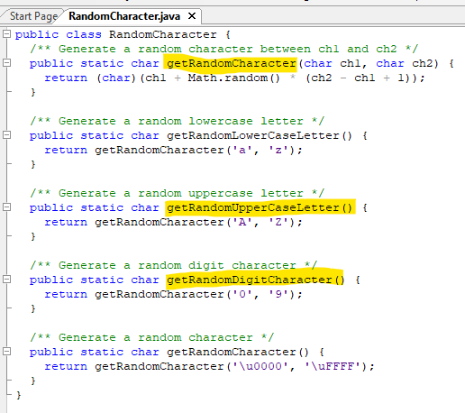

There are two ways to use these methods:

1. Use as in the text book example:



In this way, you will have two programs/classes, the program/class that you are creating and the RandomCharacter program/class.

Make sure that these two files are in the same folder.

Explaining when you are invoking/calling the methods in this manor:

You are calling the method by the class name RandomCharacter



The JVM will then go to that class (RandomCharacter) and look for the method getRandomLowerCaseLetter:



That method will then return the lower case letter



1. Use those three methods in your program/class

In this way, those methods are in one program, thus you do not need to state the program/class name to invoke/call the method.



main method:

1. state what you are doing
2. Set up the for loop to complete the following (20 iterations):
3. Call the method that will create the license plate (this method will accept nothing and return a String)
4. Print the license plate (the returned String)

Method that generates a Texas license plate:

1. Create an empty String (it will hold the characters for the license plate)
2. Create a for loop to complete the following (iterations = 8; i =0 while i < 8):
   1. Generate a random number for two choices (either upper case letter or digit; i.e. 1 = uppercase letter, 2 = digits – whatever order you wish)



* 1. Use a switch or if statement to invoke/call the method that corresponds to that random number



* 1. When you get your character back, add it to the String



* 1. When i = 3, add a space (so that it will have the format of CCC CCCC)

1. Return the String

Sample run:

20 valid Texas License Plates:

15D 98LM

…

WQ5 7CJ1